Pace University Conference Registration Account Set-Up
In order to begin applying for conference registration, you must first set up an Indico online registration account. Begin by going to the following link:
https://reg.unog.ch/user/login?returnURL=https%3A%2F%2Freg.unog.ch%2F
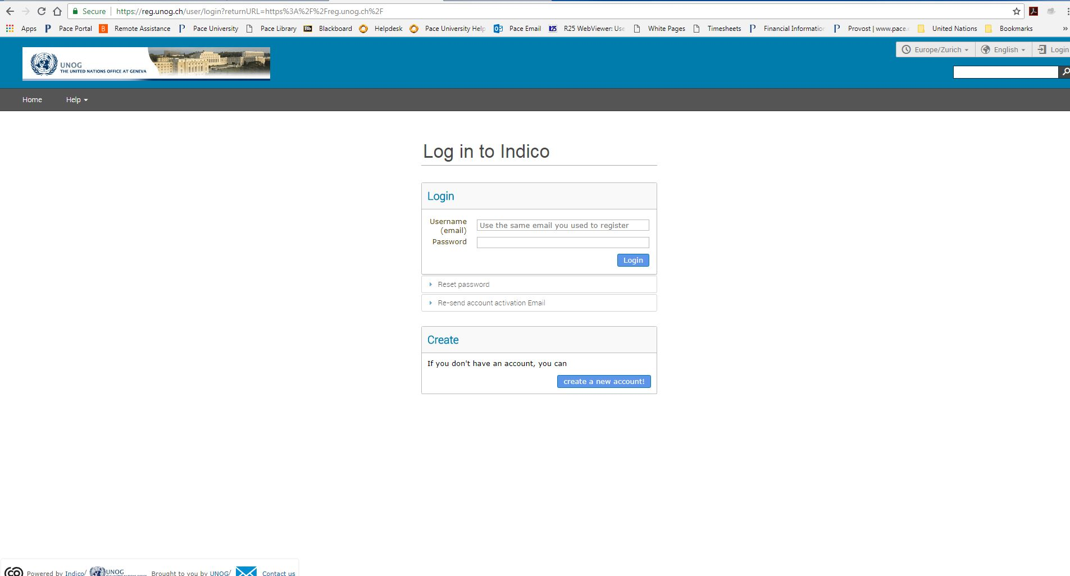
Once the link is open click, “create a new account!”

Please fill out your personal information and make sure you put “Pace University” as your Institution.
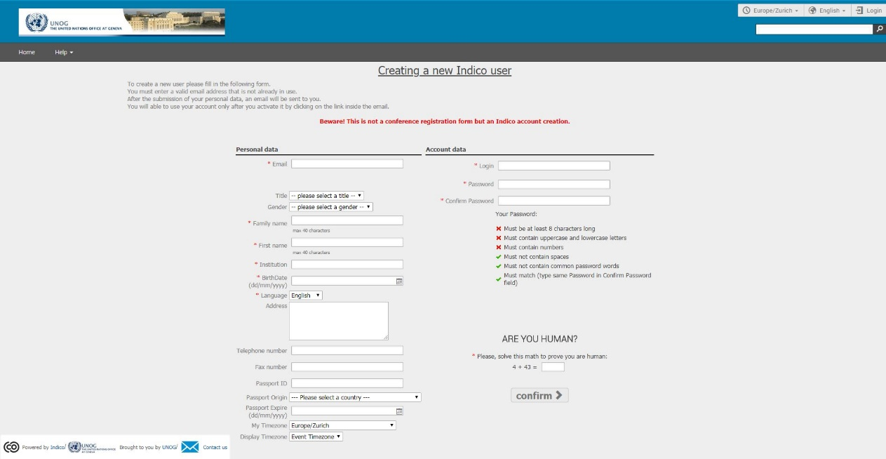
*Please note that this is not a conference registration form but an Indico account creation form.
Once you confirm your account, you will receive an email to activate your account.

How to register for a Conference or Event:
When you select an open conference to register for, a page will open to verify your details. Pace University will auto-populate into the organization field. When you reach the “Representation Type” field, please select Academia and type Pace University again. Please complete the form and click the register button.
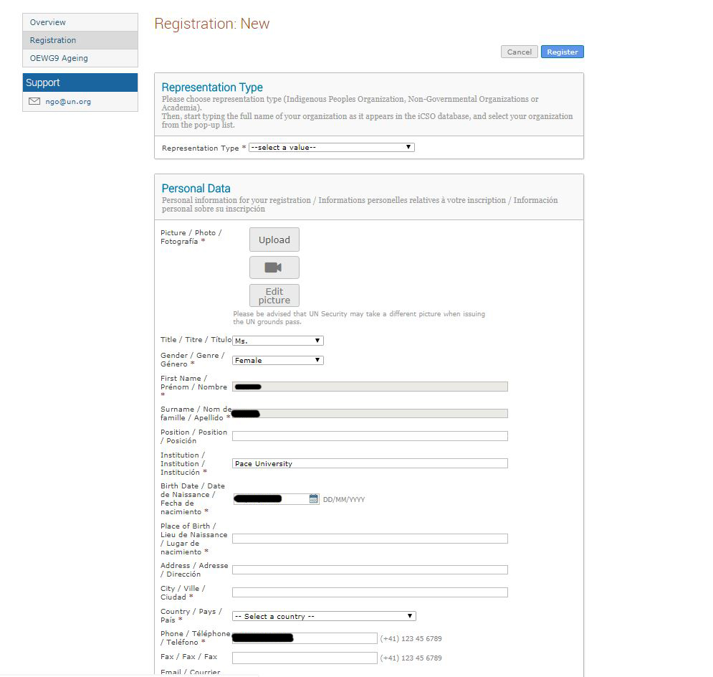
You can modify your registration request until the deadline for registration.
Once you register for a conference, please email Olivia Dituro, at odituro@pace.edu with the conference name and dates you would like to attend.
Please note that registration in Indico does not guarantee participation in any specific event. Approval of registration is up to the discretion of the conference manager and host entity.

